Cross Cut Saws

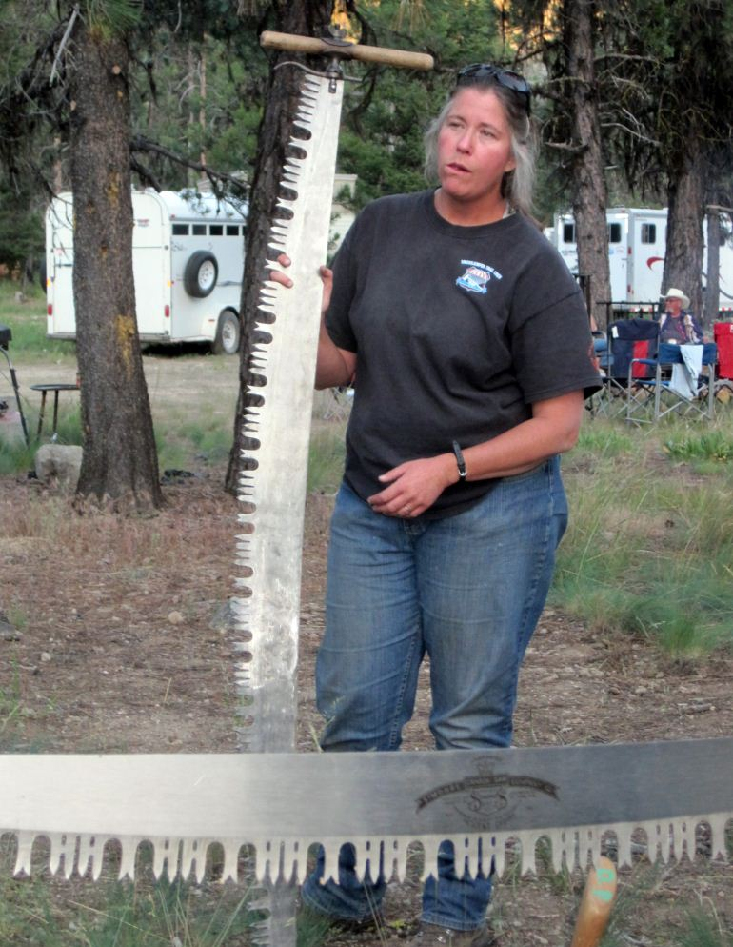

With more and more BCHA volunteers using crosscut saws to help clear wilderness trails the question comes up, how to sharpen a crosscut saw? Unlike a chainsaw that you can sharpen in the field or change a dull chain in a few minutes, crosscut saws do require some skill, special tools and a considerable amount of time to properly sharpen. With the idea of offering some support to BCHA volunteers I have put together a web page that should help with the issue. The new BCHW crosscut saw sharpening page can be found on the BCHW website under the Tech Tips link. It offers information on where or how to learn to sharpen as well as sources for some professional sharpeners. For those without web access many of the resources listed are available in other forms.
It does take some commitment of time and tools to pickup the skill but most anyone can learn to sharpen crosscut saws. There are formal week long training classes put on every year at the Nine Mile USFS Training Center, Lolo National Forest, Montana. The classes are open to anyone and the cost is reasonable. In addition the formal hands on training there is some very good information available. The USFS Crosscut Saw Manual has step by step instructions and there is a new video/DVD by the Forest Service that is scheduled to be released soon. This video is very highly rated and should prove to be a valuable learning tool. In addition to the USFS resources there is other information and training aids linked on the BCHW Crosscut saw sharpening web page.

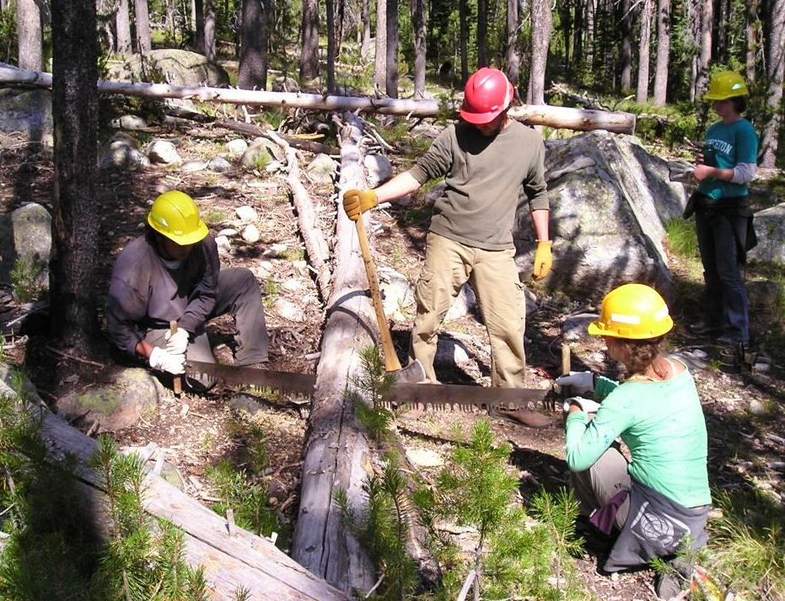

Another resource is an online crosscut saw forum at crosscutsawyer.com . This is a privately ran forum that has a wealth information on sharpening as well and other things related to crosscut saws. It is a little contradiction to have a modern internet forum for primitive tools but the knowledge of literally hundreds of years of experience from the forum members is amazing. If you do not find needed information in past posts, you can always ask.

In addition to the formal training or do it yourself learning there is the possibility of interested folks learning from BCHW members that are experienced saw filers. Both Gary Zink and myself have offered to help new filers pick up the skill. This would likely involve having members watch and ask question during a sharpening job. The timing and location of any of these sessions will depend on the interest and need. For BCHW to hold a week-long, hands-on training session is beyond the scope of any proposed training but we do have the resources to help and provide direction to anyone that is interested. No matter how a new filer picks up the skill, it will require quite an individual commitment of time and practice to become proficient.

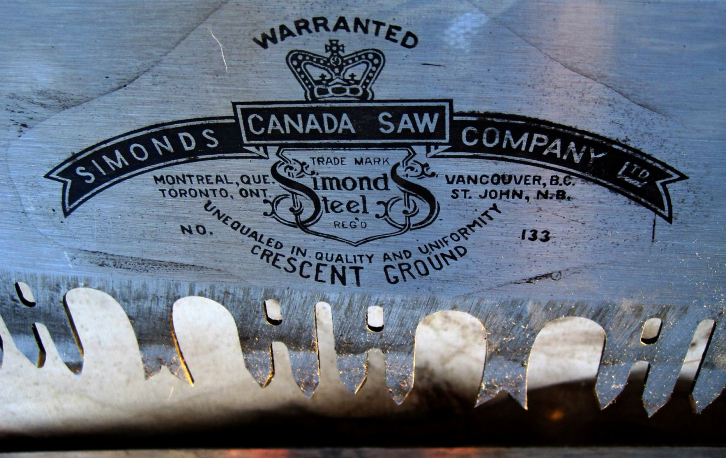

So, the main purpose of this message is to let folks know of the resources available for those that want to learn how to sharpen a saw and offer any help in the process. Please have anyone that has any questions contact me or Gary. Also, I do know that other BCHW members do sharpen saws and if they want to help out, let us know. Comments or suggestions are always welcome.
Jim Thode (Webmaster and crosscut saw user and filer)

Subject: USFS Chainsaw and Cross cut saw certification programs

Good afternoon, BCHA. There is some information in this news letter about the new Chain saw and Cross cut saw program that is in the works. BCHA and some of the states have been supplying input to the agency, USFS, about this, including bringing it to the attention of the Deputy Chief, Leslie Weldon and the Director of Wilderness, Leanne Martin at the BCHA national board meeting. It appears there will be a document to read and comment on out pretty soon. It will be interesting to see what they have come up with.

Michael K. McGlenn
Chairman BCHA

